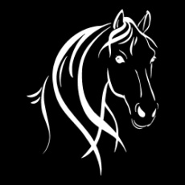 **ALBANY ADULT RIDERS CLUB Inc.**

**UNIFORM ORDER FORM 2021**

|  |  |  |  |  |  |
| --- | --- | --- | --- | --- | --- |
| Code | Item | Size | Cost | Quantity | Total |
| ZW760 | Shirt |  | $64.00 |  | $ |
| P227LS | Polo |  | $30.50 |  | $ |
| J29123 | Vest |  | $84.50 |  | $ |
|  |  |  |  | Total due | $ |

PRICES INCLUDE AARC LOGO.

An additional $5.50 for a name to garment

Name: .........................................................................................................

Payment Method: .......................................................................................

Date of order: .............................................................................................

Contact No.: ................................................................................................